Darwin Marmolejos
CIS-245-O1A
February 22, 2026
Awk Lab

1. Print all the First Names.
Command: awk '{print $1}' AwkLab.data
The awk command processes the file line by line and splits each line into fields using spaces by default. The {print $1} tells awk to print the first field of each line, which in this file is the first name. The single quotes around the command prevent the shell from interpreting the special $ character.


The output is:

2. Print phone numbers for Tom and Frodo after their names.
Command: awk -F: '/Tom |Frodo / {print $1, $2}' AwkLab.data
The /Tom |Frodo / portion is a pattern that tells awk to only process lines containing "Tom " or "Frodo " (the pipe | inside the slashes means "or" in regular expressions). The trailing space after each name ensures it matches the first name and not part of another word. When a match is found, awk prints $1 (the name) and $2 (the phone number).

The output is:
3. Print Peregrin's full name and phone number area code only.
Command: awk -F: '/Peregrin/ {split($2, a, ")"); print $1, a[1] ")"}' AwkLab.data
The pattern /Peregrin/ filters for lines containing that name. The split() function breaks the phone number field ($2) into pieces using ")" as the delimiter. The first piece, a[1], contains everything up to the closing parenthesis, which is the area code portion like "(510". Adding the ")" back gives the complete area code format. The command then prints the full name and just the area code.

The output is:

4. Print all phone numbers (full number) in the 123 area code along with the names.
Command: awk -F: '$2 ~ /\(123\)/ {print $1, $2}' AwkLab.data
The $2 ~ /\(123\)/ condition checks whether the phone number field ($2) matches the pattern (123). The ~ operator means "matches the regex." The backslashes before the parentheses (\( and \)) are needed because parentheses have special meaning in regular expressions, so they must be escaped to match literal parentheses. When a match is found, it prints the name and full phone number.

The output is:

5. Print all Last names beginning with either a T or D (careful of middle names!).
Command: awk -F: '{n=split($1, a, " "); if (a[n] ~ /^[TD]/) print a[n]}' AwkLab.data
Some people in the file have middle names (like "Adora Belle Dearheart" or "Susan Sto Helit"), so the last name is not always the second word. The split() function splits the name field into an array a using spaces, and stores the number of pieces in n. This means a[n] is always the last word, the last name in this case. The condition a[n] ~ /^[TD]/ checks if that last name starts with T or D. The ^ anchor means "beginning of string" and [TD] is a character class matching either T or D.

The output is:
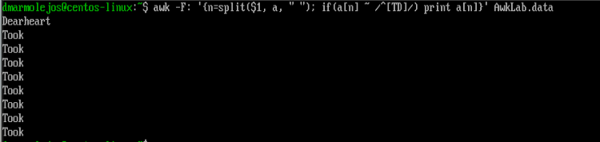

6. Print all first names containing four or less characters.
Command: awk -F: '{split($1, a, " "); if (length(a[1]) <= 4) print a[1]}' AwkLab.data
The split() function breaks the name field into words, and a[1] is the first word (the first name). The length() function returns the number of characters in a string. The if statement checks whether the length of the first name is 4 or fewer characters using the <= (less than or equal to) operator. Only names that pass this check are printed.

The output is:
7. Print the first names and area codes of all those in the 916 area code.
Command: awk -F: '$2 ~ /\(916\)/ {split($1, a, " "); print a[1], "(916)"}' AwkLab.data
The condition $2 ~ /\(916\)/ filters for lines where the phone number field contains the area code (916). The split() function extracts the first name from the name field. The command then prints the first name followed by the area code.

The output is:
8. Print Sacharissa's campaign contributions following her name. Each value should be printed with a leading dollar sign; e.g., $250 $100 $175.
Command: awk -F: '/Sacharissa/ {print $1, "$"$3, "$"$4, "$"$5}' AwkLab.data
The pattern /Sacharissa/ matches only her line. The contributions are stored in fields $3, $4, and $5 (the three values after the phone number, separated by colons). In awk, the "$" is a literal dollar sign string that gets concatenated with the field value. So "$"$3 produces output like "$250".

The output is:

9. Print last names followed by a comma and the phone number. Be careful of the last names's format.
Command: awk -F: '{n=split($1, a, " "); print a[n] ",", $2}' AwkLab.data
Same as with question 5, split() is used to handle names with middle names. The variable n holds the number of words in the name, so a[n] is always the last word (the last name). The command prints the last name followed by a comma, then the phone number. The comma between a[n] "," and $2 in the print statement adds a space between the arguments, which is awk's default output separator.

The output is:
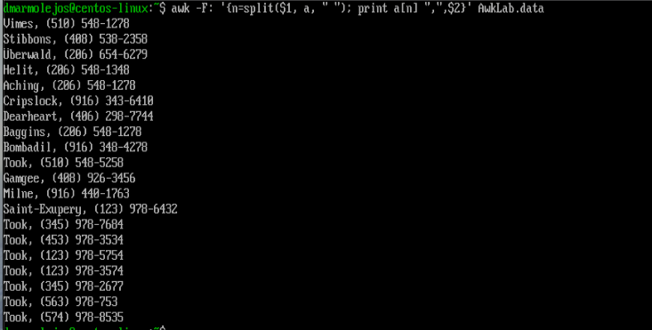
10. Print the first and last names of those who contributed more than $110 in the last month. Make sure to include their last month contribution amount after the name.
Command: awk -F: '$5 > 110 {n=split($1, a, " "); print a[1], a[n], "$"$5}' AwkLab.data
The condition $5 > 110 checks if the last (third) contribution field is greater than 110. Awk automatically treats the field as a number for the comparison. When the condition is true, it prints the first name (a[1]), the last name (a[n]), and the contribution amount with a dollar sign.

The output is:
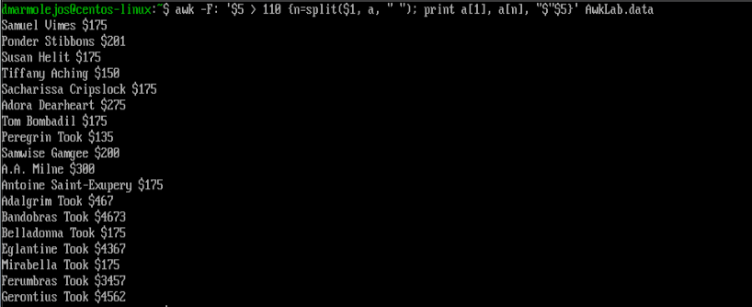

11. Print the last names, phone numbers, and first month contribution of those who contributed less than $150 in the first month.
Command: awk -F: '$3 < 150 {n=split($1, a, " "); print a[n], $2, "$"$3}' AwkLab.data
The condition $3 < 150 filters for people whose first contribution (field 3) is less than 150. When this is true, it prints the last name, the phone number ($2), and the first contribution with a dollar sign. The split() function splits the name field into an array using spaces, and n stores the number of words. This means a[n] is always the last word, which is the last name.

The output is:
12. Print the first names and contribution of those who contributed between $10 and $200 in the first month.
Command: awk -F: '$3 >= 10 && $3 <= 200 {split($1, a, " "); print a[1], "$"$3}' AwkLab.data
The condition uses the && operator, which means "and", both conditions must be true. So $3 >= 10 && $3 <= 200 means the first contribution must be between 10 and 200, inclusive. The >= means "greater than or equal to" and <= means "less than or equal to." When matched, it prints the first name and that contribution.

The output is:
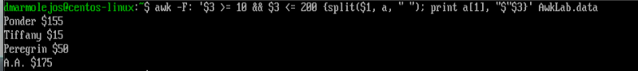
13. Print the first name, last names and total contributions of those who contributed less than $700 over the three-month period.
Command: awk -F: '{total=$3+$4+$5} total < 700 {n=split($1, a, " "); print a[1], a[n], "$"total}' AwkLab.data
This command first calculates the total of all three contributions by adding fields 3, 4, and 5 together and storing the result in a variable called total. The condition total < 700 then filters for people whose combined contributions are less than $700. Awk allows variables to be set in one block and used in the next on the same line. The first and last names are then printed along with the total.

The output is:
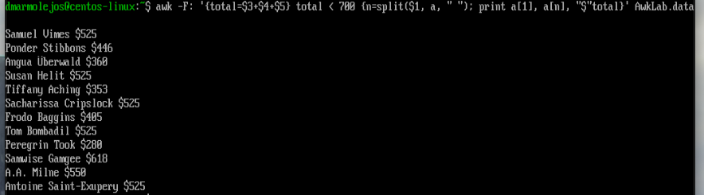
14. Print the first names and first letter of the last name, and average contribution of those who had an average contribution of more than $300.
Command: awk -F: '{avg=($3+$4+$5)/3} avg > 300 {n=split($1, a, " "); print a[1], substr(a[n],1,1), "$"avg}' AwkLab.data
This command first calculates the average by adding all three contribution fields and dividing by 3, storing the result in a variable called avg. The condition avg > 300 then filters for those with an average above $300. The split() function splits the name into an array using spaces, and a[n] gets the last word, which is the last name. The substr() function extracts part of a string, substr(a[n], 1, 1) takes the last name and returns just the first character (starting at position 1, length 1). The first name, first letter of the last name, and average contribution are then printed.

The output is:
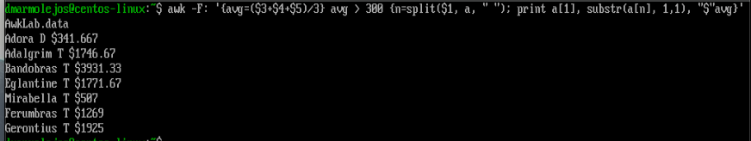
15. Print the last name and area code of those not in the 916 area code.
Command: awk -F: '$2 !~ /\(916\)/ {n=split($1, a, " "); split($2, b, ")"); print a[n], b[1] ")"}' AwkLab.data
The !~ operator is the opposite of ~, it means "does not match." So $2 !~ /\(916\)/ selects lines where the phone number does not contain (916). The backslashes escape the parentheses, so they are matched as literal characters. The split() function is used twice: first on the name field to split it into words, where a[n] gets the last word (the last name). The second split() breaks the phone number field on ")" so that b[1] contains the area code portion like "(510". Adding ")" back completes the format. The last name and area code are then printed together.

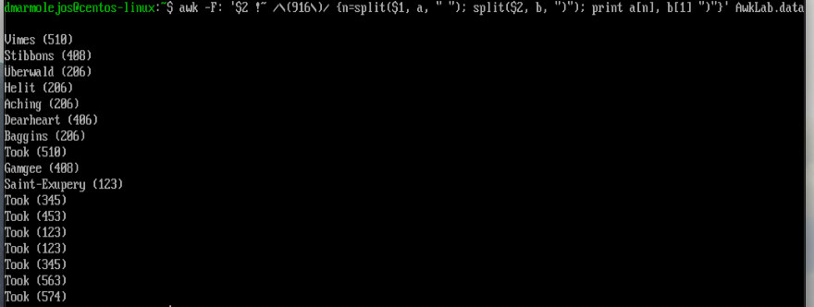
The output is:

16. Print each record preceded by the number of the record.
Command: awk -F: '{print NR, $0}' AwkLab.data
NR is a built-in awk variable that stands for "Number of Records", it automatically counts which line awk is currently processing, starting from 1. The $0 variable contains the entire current line. So this command prints the line number followed by the complete record for every line in the file.

The output is:
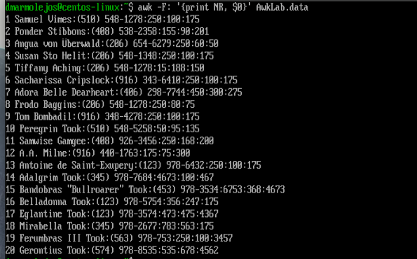
17. Print the name and total contribution of each person.
Command: awk -F: '{total=$3+$4+$5; print $1, "$"total}' AwkLab.data
The three contribution fields ($3, $4, $5) are added together and stored in a variable called total. Awk handles arithmetic automatically when fields contain numbers. The semicolon (;) separates two commands within the same block, first calculate the total, then print the full name and total with a dollar sign.

The output is:
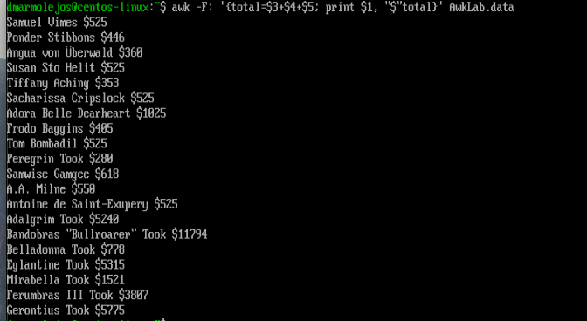
18. Add $10 to Tiffany Aching's first contribution and print her full name and first contribution.
Command: awk -F: '/Tiffany Aching/ {print $1, "$"$3+10}' AwkLab.data
The pattern /Tiffany Aching/ matches only her line. The expression $3+10 adds 10 to her first contribution value. Awk performs this math on the fly without modifying the original file. The result is printed alongside her name with a dollar sign.

The output is:
19. Change Samwise Gamgee's name to Sean Astin.
Command: awk -F: '{if ($1 == "Samwise Gamgee") $1="Sean Astin"; print $0}' OFS=: AwkLab.data
The if statement checks whether the name field exactly equals "Samwise Gamgee" using the == comparison operator. If it matches, $1 is reassigned to "Sean Astin". The OFS=: sets the Output Field Separator to a colon, so when awk rebuilds the line after modifying $1, the fields stay separated by colons just like the original format. The print $0 then outputs every line, with Samwise's line now showing the new name.

The output is:
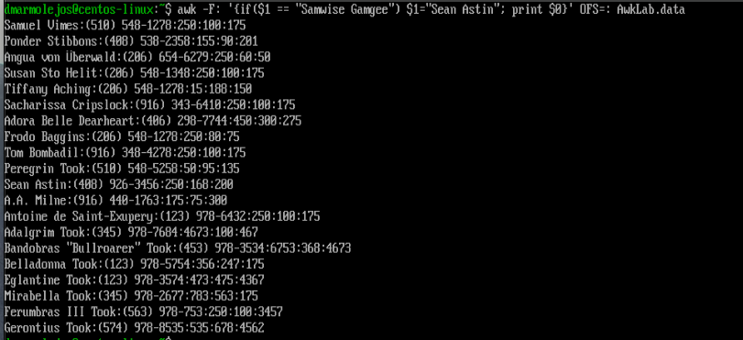

20. Write an awk script that will (actual awk script, NOT just commands on the command line)
(a) Prints first name of the all the Tooks followed by their total cam-paign contributions .
(b) Print the full names and contributions of anyone who contributed between $10 and $200 in the last contribution
(c) Prints the full names and average contribution of those who con-tributed less than $300 on average

The following awk script is saved as transform.awk and executed with the command:
awk -f transform.awk AwkLab.data

The -f flag tells awk to read its commands from a file instead of the command line. This is useful when multiple operations need to be performed, keeping the commands organized and readable.

The output is:
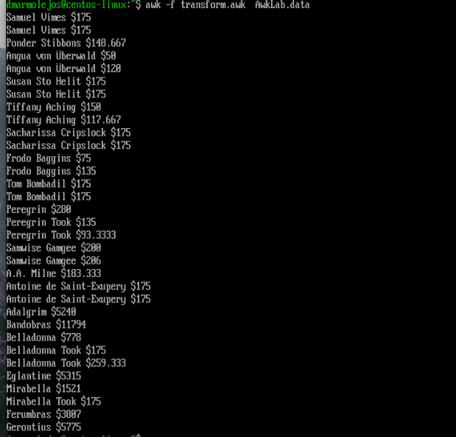

The results showed here are intervaled.

References:

Awk commands in Linux: https://www.geeksforgeeks.org/awk-command-unixlinux-examples/
The Grymoire on Awk: https://www.grymoire.com/Unix/Awk.html
Awk course notes: https://www.aholdengouveia.name/LinuxAdmin/Awk.html
GNU Awk User's Guide: https://www.gnu.org/software/gawk/manual/gawk.html
AWK Command in Linux with Examples: https://phoenixnap.com/kb/awk-command-in-linux

